The Thirteen Colonies
Use the classroom atlases to help you fill in your map and answer the questions.

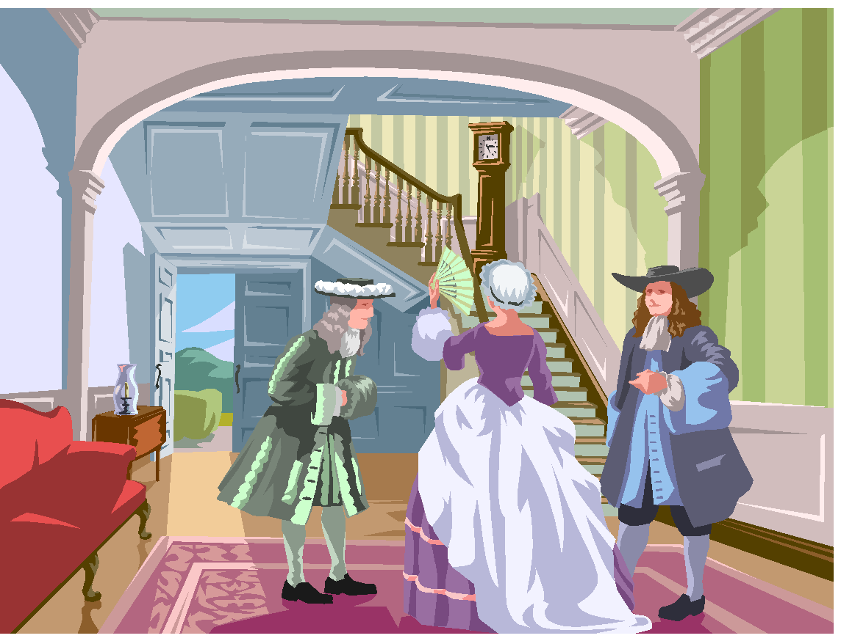

1. Label the following waters and color them blue
Atlantic Ocean Chesapeake Bay

2. Label the 13 English Colonies on your map. (pg. 22; they may be abbreviated, but must have the correct abbreviations from your atlas.)

3. Color the New England Colonies purple (pg. 24)

Color the Middle Colonies green (pg. 26)

Color the South Colonies orange (pg. 28)

4. Locate the colonial sites with a red dot and label each location.

Plymouth Salem Boston Williamsburg

Providence Hartford New Haven Charleston

Portsmouth Philadelphia Savannah Baltimore

Wilmington Perth Amboy Albany

5. Color Spanish Florida yellow. Color the land west of the 13 colonies brown. Label and color the Great Lakes blue. Label the Appalachian Mountains.

6. Create a Map Key

7. Use the blanks to answer the following questions (pgs. 22-28):

- Which of the 13 colonies was the last to be settled?________________________
- What country owned the lands west of the 13 colonies?____________________
- What country owned the land south of Georgia?__________________________

