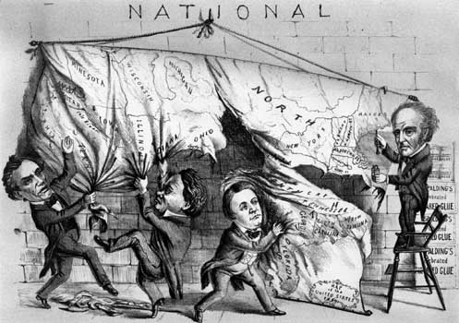
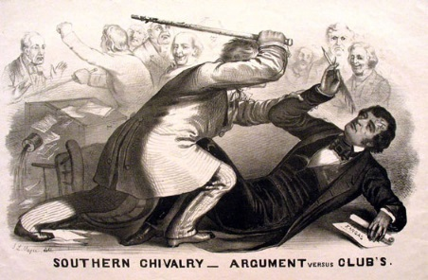
Terms
Missouri Compromise Sectionalism

Zachary Taylor Popular Sovereignty
Free Soil Party Secede
John C. Calhoun John Brown
Harriet Beecher Stowe Repeal
Bleeding Kansas Border Ruffians
Fugitive Charles Sumner
Lawsuit Franklin Pierce
Douglas Stephen Wilmot Proviso
Henry Clay Civil war
Guerilla warfare Dred Scott Decision
Compromise of 1820 Kansas-Nebraska Act
Fugitive Slave Law of 1850

